**Standard operating procedure for image analysis of LAD coronary sections using Qupath (Version 0.2.3)**

1. **Create a new project:**
   * Create project-> create an empty folder with the name of the project
   * Add images-> Set image type: Fluorescence ->Choose files -> Import
2. **Image preparation:**
   * Double click on the on the image of interest.
     1. Adjust intensity levels. Modify the maximum display by double clicking on the number.

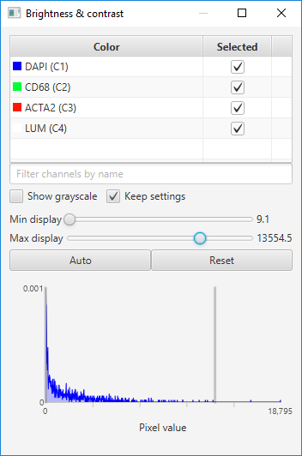

1. **Annotate the main region of interest**
   * Draw a generous annotation that corresponds to a region of interest
2. **Create training images for cell classifier**
   * Select all the images that you want to include as templates
   * Choose Classify 🡪Training image🡪 Create training image
3. **Cell detection**
   * Go to Analyze ‣ Cell detection ‣ Positive cell detection command

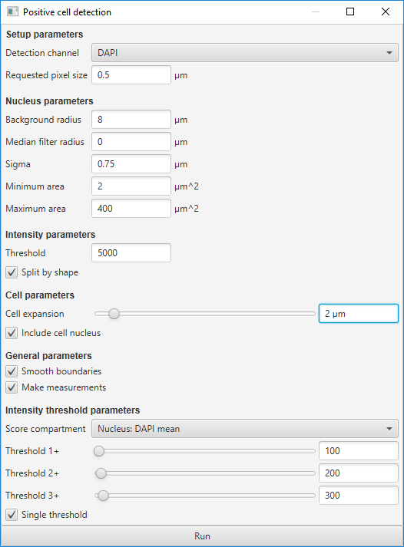

1. **Create a classifier for each marker**
   * **Create training images** 
     + - Creating duplicate images within the project for each channel that needs a classifier. To do this, choose Classify ‣ Extras ‣ Duplicate channel training images.
   * **Train & save classifiers**
     + - Double click on the on the duplicated image
       - Go to Classify ‣ Object classification ‣ Train object classifier
       - We must do is assign annotations for ‘positive’ cells with the classification we are interested in (e.g. ACTA2), and ‘negative’ cells with the special classification Ignore*. We shouldn’t use any other classes in the training annotations.
       - 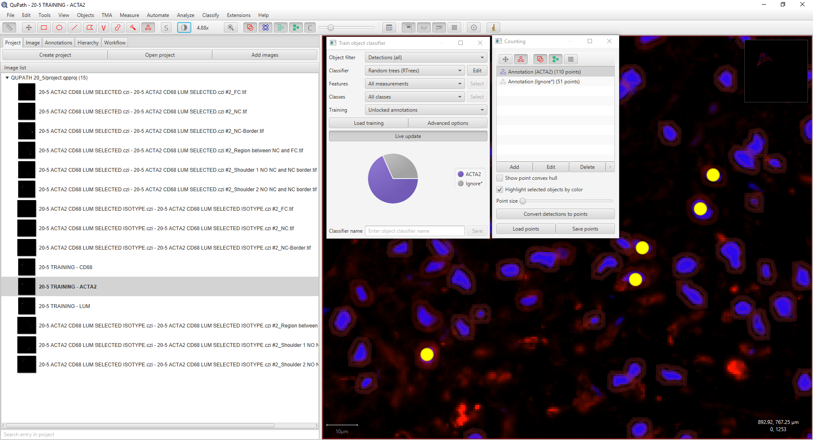Press live update
       - Once positive and negative cells are correctly detected, enter a name to identify your classifier and save it.
2. **Combine the classifiers**
   * Return to your original image that you want to classify and choose Classify ‣ Object classification ‣ Load object classifier.
   * This should display all the classifiers available within the project.

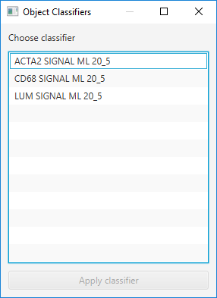

* + Go to the tool bar, select  and show annotation measurements
  + Copy to clipboard and paste the data on an excel file.